- Florida Department of Education  Parent Survey-  Exceptional Student education  ___________________________________________________  ESE Parent Survey  The Florida Department of Education is working with school districts across the state to gather information on how well parents of students with disabilities think their child's school is partnering with them to provide effective instruction, services, and supports.  Your responses will help guide efforts to improve these services and educational supports for children and families in Santa Rosa County. This survey is for parents of students with individual educational plans (IEP) receiving special education services during the 2020-2021 school year. All information provided will remain confidential.  Your responses to the survey provide important information for planning and monitoring improvement activities. You may submit one online survey for each child receiving services.  Please take a few minutes to complete this survey before May 31, 2021. By completing the survey your child’s school could earn a monetary reward. Assistance with completing the survey can be obtained through the school’s liaison or by contacting the district’s ESE Department.  This survey provides you as a parent with an  opportunity to be heard.  ____________________________________________________  - Survey Period: Feb.1-May 31  Survey Link: www.esesurvey.com | When: Feb.1-May 31  ____  Who: All parents of children with IEP’s in PreK-12th grade  ____  How: Go Online to www.esesurvey.com  ____  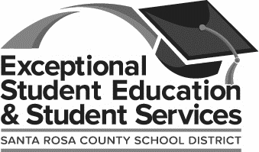  What can you do? Complete the survey, your input matters.  ____  DouGlas A. Dillon ADmin Complex  6032 Highway 90  850-983-5150  http://santarosacountyesedepartment.weebly.com/

